Massachusetts Society of Pathologists, Inc
MSP Fall Meeting
October 20, 2026
The Conference Center at Waltham Woods
860 Winter St, Waltham, Ma 02451
Dinner tickets: $60.00
Registration Link:
Agenda
5:55 PM Welcome and introductory comments
6:00 PM Susan Lester, MD, PHD, Chief, Breast Pathology
6:30 PM Amy Ly, MD, Assistant Pathologist, MGH
7:00 PM Lija Joseph, MD, Chief of Pathology, Lowell General Hospital
7:30 PM Dinner
8:30 PM End of Meeting

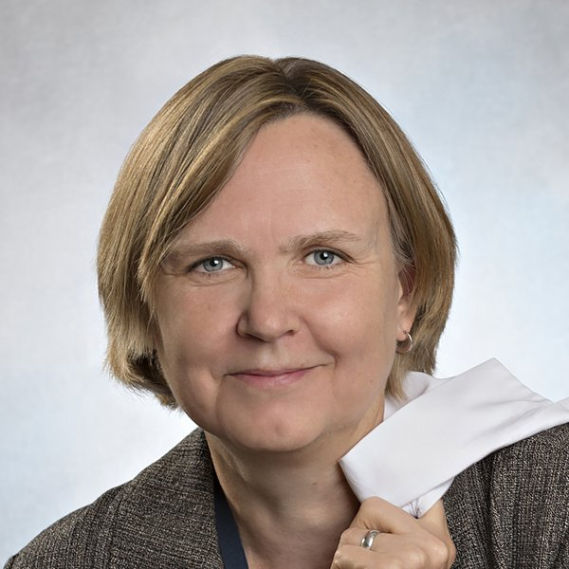

“Understanding Litigation Risk in Breast Pathology”
6:00 PM Susan Lester MD, PHD,
Chief, Breast Pathology
Assistant Professor, Harvard Medical School
==================================================================
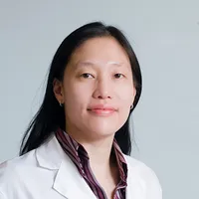
“ Learn Strategies to Mitigate Risk in Breast Pathology”
6:30 PM Amy Ly, MD - Assistant Pathologist, Massachusetts General Hospital lAssociate Professor of Pathology, Harvard Medical School

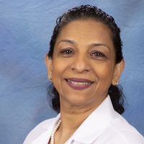
“Understand and Mitigate Risk in Cybersecurity in Pathology Practice”
7:00 PM Lija Joseph, MD, FCA
Chief, Pathology, Lowell General Hospital, Medical Director, Pathology and Laboratory Medicine, Lowell General Hospital

Learning Objectives
- Understand litigation risk in breast pathology
- Learn strategies to mitigate risk in breast pathology
- Understand and mitigate risk in cybersecurity in pathology practice

Joint Provider ship Accreditation Statement: This activity has been planned and implemented in accordance with the accreditation requirements and policies of the Accreditation Council for Continuing Medical Education (ACCME) through the joint provider ship of the College of American Pathologists and Massachusetts Society of Pathologists. The College of American Pathologists is accredited by the ACCME to provide continuing medical education for physicians.
Credit Designation Statement; The College of American Pathologists designates this internet live educational activity for a maximum of 1.50 AMA PRA Category 1 Credit(s)™. Physicians should claim only credit commensurate with the extent of their participation in the activity.
Disclaimer: The content of this CME activity does not necessarily reflect the view or policies of the College of American Pathologists.

Disclosure Information: Below you will find the financial disclosure relationships for anyone who was able to affect the content of this educational activity. The CAP mitigates all the relevant financial relationships listed for these individuals.

The following speakers/planners have no financial relationships to disclose:
Lija Joseph, MD
Susan Lester, MD

The following speaker has disclosed financial relationships with ineligible companies:
Amy Ly, MD is a consultant at Ultivue Inc (a biotech company)

The following In-Kind & Commercial Support has been received for this activity: NONE

******************************************************************************

